S3- SIMPLE STORAGE SERVICE

PUBLIC BUCKET-

Objectives-
- Create a bucket in Amazon S3.
- Upload an object to a bucket.
- Manage access permissions for both objects and buckets.
- Create and apply a bucket policy.
- Enable and utilize bucket versioning.

Step 1: Accessing Amazon S3
To begin working with Amazon S3, follow the steps below:
- Log in to the AWS Management Console using your credentials.
- Locate the search bar at the top of the console interface.
- Type S3 in the search bar and select Amazon S3 from the displayed results.
- Upon selection, the Amazon S3 dashboard will open.
- Click on the Create bucket button to initiate the process of creating a new S3 bucket.
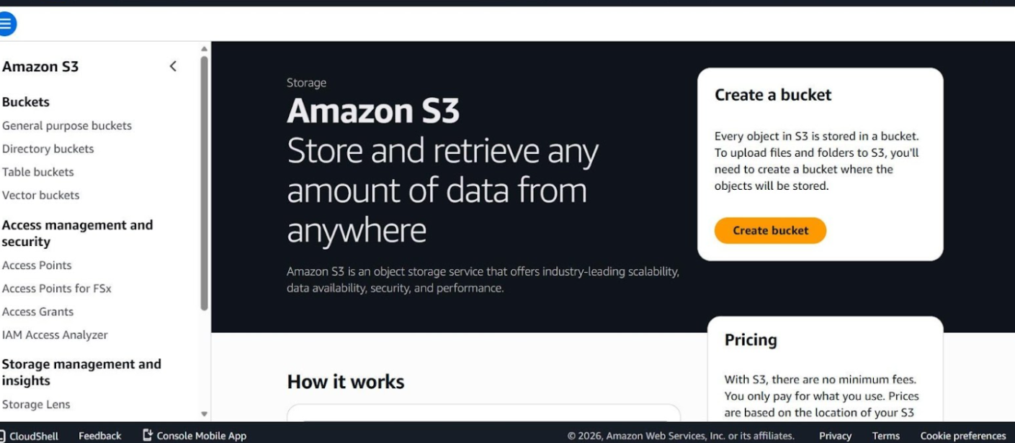

Step 2: Defining Bucket Type and Name
In this step, you will specify the basic configuration options on the Create bucket page:
- Choose General purpose as the bucket type.
- Select either Global namespace (default) or Account Regional namespace.
- Provide a unique name for the bucket.
- Scroll down to the Object Ownership section. Select ACLs enabled. All objects are owned by your AWS.
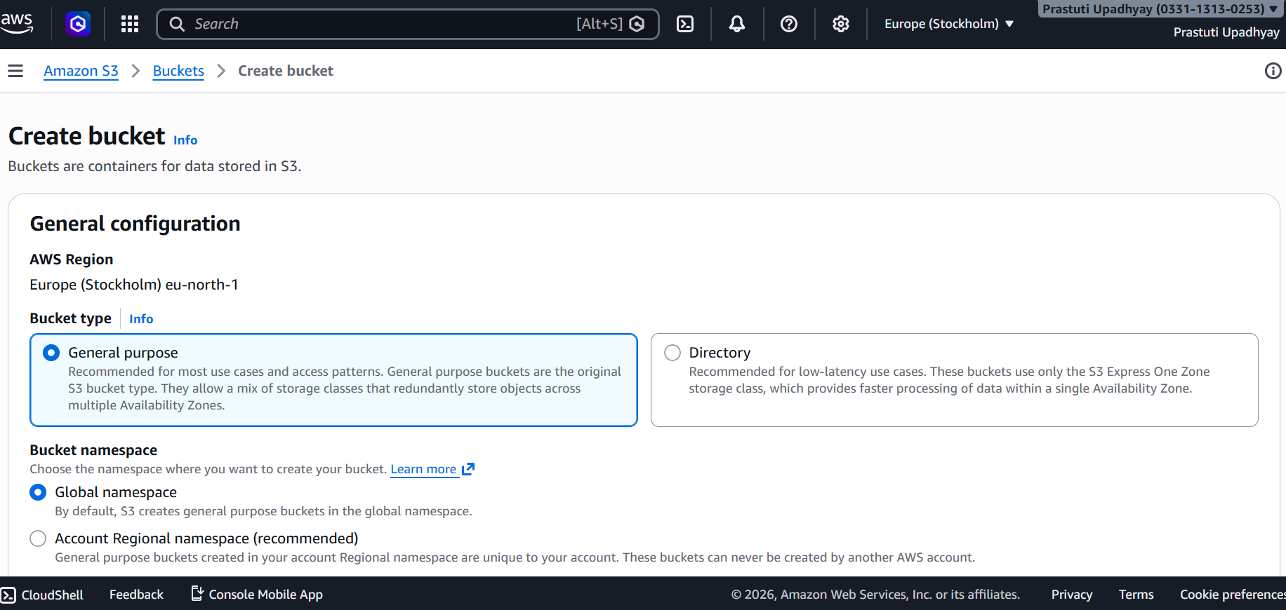
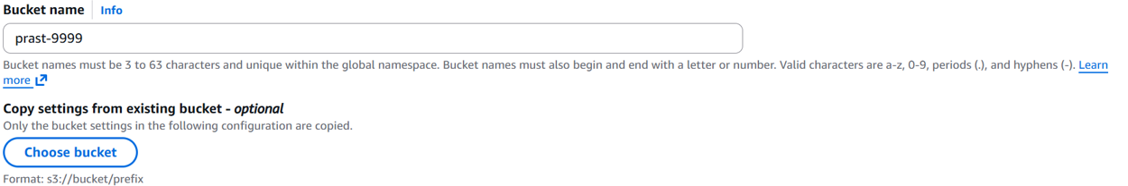
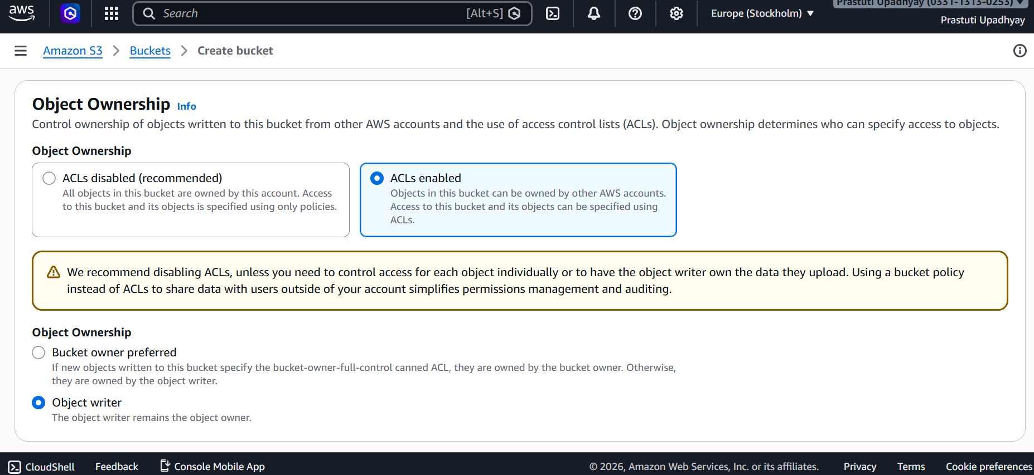

Step 3: Configure Public Access Settings
- Disable the option Block all public access by selecting the checkbox.
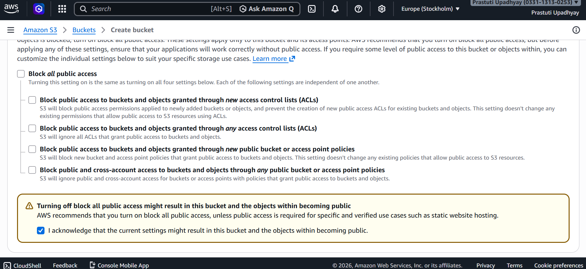

Step 4: Configure Default Encryption
In this step, set up encryption for your bucket:
- Navigate to the Default encryption section by scrolling down the page.
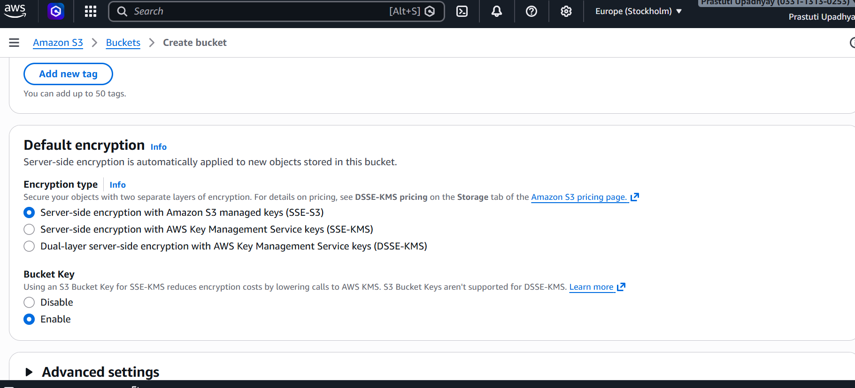

Step 5: Upload a File to the Bucket
After creating the bucket, follow these steps to upload files:
- Open your bucket and click on Upload.
- Drag and drop files, or use Add files / Add folder to select them.
- The selected files will be displayed in the list.
- Verify the destination bucket, then click Upload to complete the process.
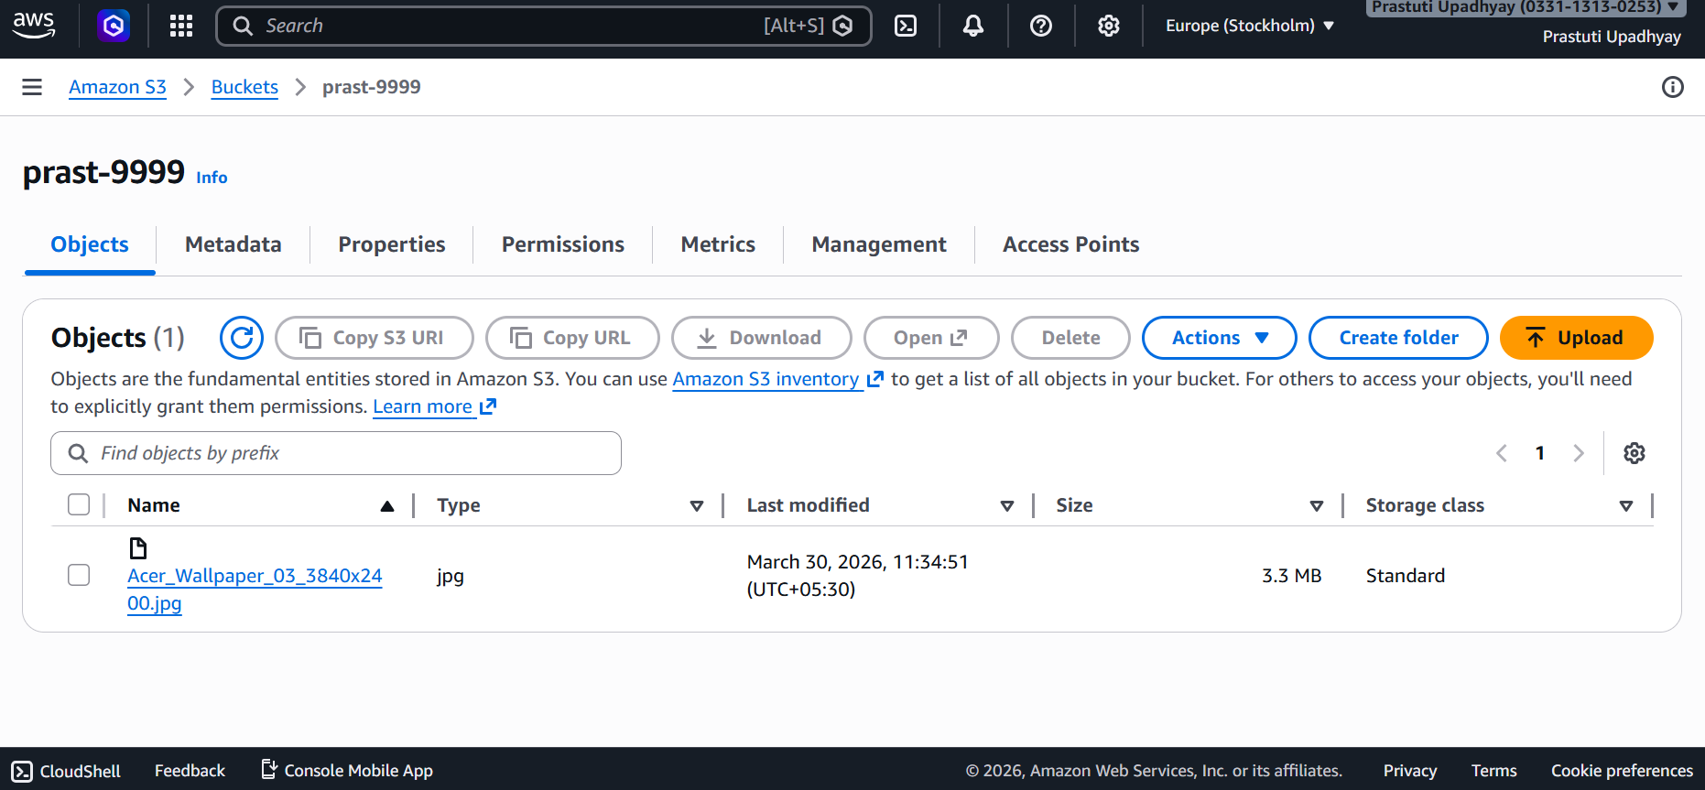
Step 6: Modify the Access Control List (ACL) to make the object publicly accessible
